CERTIFIED TRUE COPY; Ministry of Information and Communications; October 29, 2021 16:28:49
MINISTRY OF INFORMATION AND COMMUNICATIONS  --------------------  No. 10/2021/TT-BTTTT | SOCIALIST REPUBLIC OF VIETNAM  Independence – Freedom – Happiness  --------------------  Hanoi, October 28, 2021
CIRCULAR
Promulgating “National technical regulation on short range device (SRD) - Radio equipment to be used in the 40 GHz to 246 GHz frequency range”
--------------------
Pursuant to the Law on Standards and Technical Regulations dated June 29, 2006;
Pursuant to the Law on Telecommunications dated November 23, 2009;
Pursuant to the Law on Radio Frequencies dated November 23, 2009;
Pursuant to Decree No. 127/2007/ND-CP dated August 1, 2007 of the Government detailing and guiding the implementation of a number of articles of the Law on Standards and Technical Regulations;
Pursuant to Decree No. 78/2018/ND-CP dated May 16, 2018 of the Government amending and supplementing a number of articles of the Decree No. 127/2007/ND-CP dated August 1, 2007 of the Government detailing the implementation of a number of articles of the Law on Standards and Technical Regulations;
Pursuant to Decree No. 17/2017/ND-CP dated February 17, 2017 of the Government defining the functions, tasks, powers and organizational structure of the Ministry of Information and Communications;
At the proposal of the Director General of the Department of Science and Technology,
The Minister of Information and Communications hereby promulgates the Circular stipulating the national technical regulation on short range device (SRD) - Radio equipment to be used in the 40 GHz to 246 GHz frequency range.
Article 1. This Circular is promulgated together with the National Technical Regulation on short range device (SRD) -Radio equipment to be used in the 40 GHz to 246 GHz frequency range (QCVN 123: 2021/BTTTT).
Article 2. This Circular is effective from July 01, 2022.
Article 3. The Chief of Office, Director General of the Department of Science and Technology, Heads of agencies and units under the Ministry of Information and Communications, Directors of Departments of Information and Communications of provinces and centrally run cities and relevant organizations and individuals shall implement this Circular./.

Recipients:  - Prime Minister, Deputy Prime Ministers (for reporting);  - Ministries, ministerial-level agencies, agencies under the Government;  - People's Councils and People's Committees of provinces and centrally run cities;  - Office of the Party Central Committee and Party Committees;  - Office of the National Assembly;  - Office of the President;  - Supreme People's Court of Vietnam;  - Supreme People's Procuracy of Vietnam;  - Departments of Information and Communications of provinces and centrally run cities;  - Department of Examination of Legal Documents (Ministry of Justice);  - Official Gazette, Vietnam Government Portal;  - Ministry of Information and Communications: Ministers and Deputy Ministers, agencies and units under the Ministry, the Ministry's portal;  - Storage: Archives, Science and Technology (250). | MINISTER  (Signed & sealed)  Nguyen Manh Hung

SOCIALIST REPUBLIC OF VIETNAM

QCVN 123:2021/BTTTT
NATIONAL TECHNICAL REGULATION ON SHORT RANGE DEVICE (SRD) - RADIO EQUIPMENT TO BE USED IN THE 40 GHZ TO 246 GHZ FREQUENCY RANGE

Hanoi – 2021

CONTENTS
1. GENERAL PROVISIONS 5
1.1. Scope of regulation 5
1.2. Subjects of application 5
1.3. Normative references 5
1.4 Interpretation of terms 6
1.5 Symbols 7
1.6 Abbreviations 8
2. TECHNICAL SPECIFICATIONS 8
2.1. Requirements for transmitters 8
2.1.1. RF output power 8
2.1.2 Permitted operating frequency range 9
2.1.3. Out-of-band emissions 9
2.1.4. Spurious emission 11
2.2. Requirements for receivers 12
2.2.1. Unwanted emissions 12
3. MEASUREMENT METHODS 13
3.1. Requirements for test 13
3.1.1. Environmental conditions for testing 13
3.1.2 Selection of equipment for testing 14
3.1.3. Interpretation of measurement results 14
3.1.4. Tests in the frequency band above 110 GHz 15
3.2. Test on transmitters 15
3.2.1. RF output power measurement 15
3.2.2. Measurement of permitted operating frequency range 15
3.2.3. Measurement of out-of-band emissions 17
3.2.4. Measurement of spurious emissions 18
3.3. Test on receivers 19
4. REQUIREMENTS FOR MANAGEMENT 20
5. RESPONSIBILITIES OF ORGANIZATIONS AND INDIVIDUALS 20
6. ORGANIZATION OF IMPLEMENTATION 20
Appendix A (Normative) Radiation measurements 21
Appendix B (Normative) General conditions 24
Appendix C (Informative) Atmospheric absorption and material dependent attenuations 33
Appendix D (Normative) Regulations on the HS codes of short range devices to be used in the 40 GHz to 246 GHz frequency range 36
Appendix E (Informative) 37
Bibliography of References 43

Preface
QCVN 123:2021/BTTTT compiled by the Authority of Telecommunications, submitted by the Department of Science and Technology, appraised by the Ministry of Science and Technology, and issued by the Ministry of Information and Communications together with Circular No. ……./TT -BTTTT dated …….., 2021

NATIONAL TECHNICAL REGULATION ON SHORT RANGE DEVICE (SRD) - RADIO EQUIPMENT TO BE USED IN THE 40 GHZ TO 246 GHZ FREQUENCY RANGE

1. GENERAL PROVISIONS

1.1. Scope of regulation
This Regulation applies to general types of transmitting device, short range device (SRD) – radio transmitting and receiving equipment, including the equipment used for alarms, telemetry, telecommand, data transmission, operating in the 40 GHz to 246 GHz frequency range specified in Table 1 of this Regulation in the following cases:
- With a radio frequency output connection and dedicated antenna or with an integral antenna;
- With all types of modulation;
- Fixed stations, mobile stations and portable stations.
Table 1 – Frequency bands used for short range devices within the 40 GHz to 246 GHz frequency range
Frequency Band | Applications
61.0 GHz to 61.5 GHz | Use for general purposes
122 GHz to 123 GHz
244 GHz to 246 GHz
This Regulation applies to products and goods that are short range devices - radio equipment with HS codes specified in Appendix D.

1.2. Subjects of application
This Regulation applies to Vietnamese and foreign agencies, organizations and individuals engaged in the production and business of equipment covered by this Regulation in the Vietnamese territory.

1.3. Normative references
ETSI TR 100 028 (V1.4.1) (all parts): “Electromagnetic compatibility and Radio spectrum Matters (ERM); Uncertainties in the measurement of mobile radio equipment characteristics”.
CEPT/ERC Recommendation 74-01: “Unwanted emissions in the spurious domain”, Hradec Kralove, Cardiff 2011.
Recommendation ITU-R SM.329-12 (09/2012): “Unwanted emissions in the spurious domain, SM Series, Spectrum management”.
CISPR 16 (2006) (parts 1-1, 1-4 and 1-5): “Specification for radio disturbance and immunity measuring apparatus and methods”.
ETSI TR 102 273 (V 1.2.1) (all parts): “Electromagnetic compatibility and Radio spectrum Matters (ERM); Improvement on Radiated Methods of Measurement (using test site) and evaluation of the corresponding measurement uncertainties”.
Recommendation ITU-T O.153: “Basic parameters for the measurement of error performance at bit rates below the primary rate”.
ETSI TS 103 052: “Electromagnetic compatibility and Radio spectrum Matters (ERM); Radiated measurement methods and general arrangements for test sites up to 100 GHz”.

1.4 Interpretation of terms
1.4.1 Alarm
Use of radio communication for indicating an alarm condition at a distant location
1.4.2 Artificial antenna
Non-radiating dummy load equal to the nominal impedance specified by the manufacturer
1.4.3 Assigned frequency band
Frequency band within which the device is authorized to operate and to perform the intended functions of the device.
1.4.4 Dedicated antenna
Removable antenna supplied and tested with the radio equipment, designed as an indispensable part of the equipment
1.4.5 Direct sequence spread spectrum
Form of modulation where a combination of data to be transmitted and a fixed code sequence is used to directly modulate a carrier, e.g. by phase shift keying.
NOTE: The code rate determines the occupied bandwidth.
1.4.6 Environmental profile
Range of environmental conditions under which equipment within the scope of this regulation is required to comply with the provisions of this regulation.
1.4.7 Fixed station
Equipment intended for use in a fixed location
1.4.8 Frequency hopping spread spectrum
Spread spectrum technique in which the transmitter signal occupies a number of frequencies in time, each for some period of time, referred to as the dwell time
NOTE: Transmitters and receivers follow the same frequency hop pattern. The number of hop positions and the bandwidth per hop position determine the occupied bandwidth.
1.4.9 Integral antenna
Permanent fixed antenna, which may be built-in, designed as an indispensable part of the equipment
1.4.10 Mobile station
Equipment normally fixed in a vehicle or used as a transportable station.
1.4.11 Necessary bandwidth
Width of the emitted frequency band which is sufficient to ensure the transmission of information at the rate and with the quality required under specified conditions
NOTE: The necessary bandwidth including the frequency tolerances is accommodated within the assigned frequency band.
1.4.12 Occupied bandwidth
Width of a frequency band such that, below the lower and above the upper frequency limits, the mean powers emitted are each equal to 0,5 % of the total mean power of a given emission
NOTE: This corresponds to the -23 dBc bandwidth of the signal.
1.4.13 Operating frequency
Nominal frequency at which equipment is operated; this is also referred to as the operating center frequency
NOTE: Equipment may be able to operate at more than one operating frequency.
1.4.14 Operating frequency range
Range of operating frequencies over which the equipment can be adjusted through tuning, switching or reprogramming
1.4.15 Portable station
Equipment that may be carried
1.4.16 Power spectral density
Ratio of the amount of power to the used radio measurement bandwidth
NOTE: It is expressed in units of dBm/Hz or as a power in dBm with respect to the used bandwidth. In case of measurement with a spectrum analyser the measurement bandwidth is equal to the RBW.
1.4.17 Radiated measurements
Measurements which involve the absolute measurement of a radiated field
1.4.18 Spread spectrum
Modulation technique in which the energy of a transmitted signal is spread throughout a large portion of the frequency spectrum
1.4.19 Ultra low power equipment
Equipment using transmit envelope power below the receiver and idle/standby transmitter limits given in CEPT/ERC Recommendation 74-01.
1.4.20 Unwanted emissions
Emission on a frequency or frequencies which are outside the necessary bandwidth and the level of which may be reduced without affecting the corresponding transmission of information
NOTE: Unwanted emissions include harmonic emissions, parasitic emissions, intermodulation products and frequency conversion products.

1.5 Symbols
dB deciBel
dBc Relative deciBel (compared to the maximum power density of the transmitted signal)
dBm decibel corresponding to 1mW
f Frequency
P Power
t Time
λ Wavelength

1.6 Abbreviations
BW | Bandwidth
CEPT | European Conference of Postal and Telecommunications Administrations
CISPR | Comité international special des perturbations radioélectriques
e.i.r.p. | equivalent isotropical radiated power
e.r.p. | effective radiated power
ERC | European Radiocommunication Committee
EUT | Equipment Under Test
FHSS | Frequency Hopping Spread Spectrum
FSL | Free Space Loss
NSA | Normalized Site Attenuation
OATS | Open Area Test Site
OBW | Occupied Bandwidth
OOB | Out-of-Band
PD | Power Density
PDL | Power Density Limit
PSD | Power Spectral Density
R&TTE | Radio and Telecommunications Terminal Equipment
RBW | Resolution Bandwidth
RF | Radio Frequency
RMS | Root Mean Square
SRD | Short Range Device
TX | Transmitter
VBW | Video Bandwidth

2. TECHNICAL SPECIFICATIONS
The technical specifications of this regulation apply in the operating environment of the equipment which shall be declared by the manufacturer. The equipment shall comply with all technical requirements of this regulation when operating within the boundary limits of the declared operating environment.

2.1. Requirements for transmitters

2.1.1. RF output power
2.1.1.1. Definition
The RF output power is the mean equivalent isotropic radiated power during the transmission of a data package. In the case of equipment performing power control, the mean e.i.r.p. is the highest power level of the transmitter power control range during the transmission cycle.
2.1.1.2. Limits
The maximum RF output power corresponds to the system operating at the highest declared power level. For smart antenna systems and directional antennas, this limit corresponds to the configuration which results in the highest e.i.r.p.
The RF output power limit in the broadband operation mode shall not exceed the value specified in Table 2 below.
Table 2 - RF output power limits
Frequency Band | RF output power (e.i.r.p.) | Applications | Remarks
61.0 GHz to 61.5 GHz | 100 mW (20 dBm) | Use for general purposes
122 GHz to 123 GHz | 100 mW (20 dBm) | Use for general purposes
244 GHz to 246 GHz | 100 mW (20 dBm) | Use for general purposes
2.1.1.3. Measurement methods
The measurement methods are specified in 3.2.1.

2.1.2 Permitted operating frequency range
2.1.2.1. Definition
The permitted operating frequency range is the frequency range over which the equipment is authorized to operate. The manufacturer shall declare the permitted operating frequency range.
f_{L} means the lowest operating frequency and f_{H} means the highest operating frequency. If equipment is able to operate in different modes and on different frequency bands, these frequencies shall be reported for each mode and frequency band.
2.1.2.2. Limits
The frequency range of the equipment measured from the lowest frequency (f_{L}) to the highest frequency (f_{H}) is limited by the power spectrum envelope. In equipment that allows adjustment or selection of different operating frequencies, the power envelope occupies different positions in the allocated frequency band. This frequency range is defined by the lowest values ​​f_{L} and the highest values ​​f_{H}, determined from the adjustment of the device from the lowest operating frequency to the highest operating frequency.
The occupied bandwidth (equal to 99% of the wanted radiated power) and the required bandwidth shall be within the assigned frequency band.
The operating frequency range of the equipment shall be within the frequency band segments specified in Table 1 of this Regulation.
2.1.2.3. Measurement methods
The measurement methods are specified in 3.2.2.

2.1.3. Out-of-band emissions
According to CEPT/ERC recommendation 74-01 and Recommendation ITU-R SM.329-12, the boundary between the out-of-band emission domain and spurious emission domain is ±250 % of the required bandwidth from the central emission frequency.
2.1.3.1. Definition
Out-of-band emissions are emissions on one or more frequencies outside the required bandwidth, resulting from a modulation process, but excluding spurious emissions.
Out-of-band emissions are determined in accordance with a measurement of the mean spectral density (e.i.r.p.) under normal operating conditions.
The measurement results of f_{H} and f_{L} are used to determine the occupied bandwidth of the device.
The occupied bandwidth (f_{H} - f_{L}) is used to determine the out-of-band emission domain and spurious emission domain.
2.1.3.2. Limits
The boundary values of the out-of-band emission domain and spurious emission domain ​​depend on the occupied bandwidth of the EUT.
The boundary limit is determined as follows:
F1 = center frequency of OBW [GHz] - (2.5 * (f_{H} - f_{L}))
F2 = center frequency of OBW [GHz] + (2.5 * (f_{H} - f_{L}))
Where, the center frequency of the OBW is the center frequency of the signal.
This calculation is given to determine the out-of-band and spurious emission domain boundaries, which will be greater than/less than the maximum value in the permitted operating range (see Figure 1).
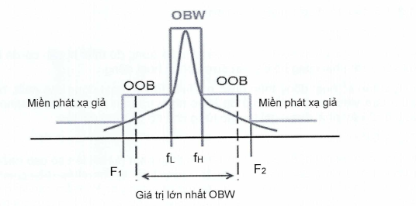
Maximum value of OBW
Spurious emission domain
Spurious emission domain
Figure 1 - Overview of OOB/spurious emission dependence on OBW
In addition, it is possible to calculate F₁/F₂ as follows: If F₁/F₂ is considered as the theoretical lower or upper frequency which come out of the calculation based on 250 % of the maximum value of the OBW (see Table 2). Therefore, the amplitude between OOB and spurious emission will be fixed at the frequency given in Table 3 below (normally F₁/F₂ is calculated as 250 % of the center frequency of the signal).
Table 3 - Limits of frequency values F1 and F2, based on the maximum theoretical OBW of the EUT
Frequency Band | Center frequency | Maximum OBW | F1 | F2
61.0 GHz to 61.5 GHz | 61.25 GHz | 500 MHz | 60 GHz | 62.5 GHz
122 GHz to 123 GHz | 122.5 GHz | 1 GHz | 120 GHz | 125 GHz
244 GHz to 246 GHz | 245 GHz | 2 GHz | 240 GHz | 250 GHz
The value of the radiated power density based on the RMS value in the OOB range (between F₁ ≤ f < f_{L} and f_{H} < f ≤ F₂) shall not exceed the values specified in Tables 4 and 5 below.
Table 4 - Out-of-band emission domain
Frequency [GHz] | RMS power density [dBm/MHz]
F₁ ≤ f < f_{L} | See Table 6
f_{H} < f ≤ F₂ | See Table 6
Table 5: Limits for out-of-band radiation
Frequency band | OOB limit [dBm/MHz]
61.0 GHz to 61.5 GHz | -10 dBm/MHz
122 GHz to 123 GHz | -10 dBm/MHz
244 GHz to 246 GHz | -15 dBm/MHz

2.1.3.3. Measurement methods
The measuring methods are specified in 3.2.3

2.1.4. Spurious emission
2.1.4.1. Definition
Spurious emissions are emissions on one or more frequencies that are outside the required bandwidth and whose value can be reduced without affecting the transmission of information. Spurious emissions include harmonic emissions, parasitic emissions, intermodulation components and frequency conversion components, but exclude out-of-band emissions.
Spurious emissions are measured as power spectral density under normal operating conditions. According to CEPT/ERC recommendation 74-01 and Recommendation ITU-R SM.329-12, the boundary between spurious and out-of-band emission domains emission is ±250 % of the required bandwidth of the center frequency emission.
The frequency ranges to be evaluated in the spurious emission domain are:
- Frequency f < F₁ [GHz]
and
- Frequency f > F₂ [GHz]
The way to determine the values ​​of these frequencies is given in 2.1.3.2, the minimum and maximum values ​​are given in Table 3 above.
2.1.4.2. Limits
The power of spurious emissions shall not exceed the values ​​specified in Table 6 below.
Table 6 - Spurious emission limits
Frequency range (MHz) | Limit values for spurious emission | Type of detector
47 to 74 | -54 dBm e.r.p. | Quasi-peak
87.5 to 118 | -54 dBm e.r.p. | Quasi-peak
174 to 230 | -54 dBm e.r.p. | Quasi-peak
470 to 862 | -54 dBm e.r.p. | Quasi-peak
Otherwise in frequency bands 30 to 1 000 | -36 dBm e.r.p. | Quasi-peak
1 000 to 300 000 | -30 dBm e.i.r.p. | Mean value  (See NOTE)
NOTE: Parameters to be set up for testing
- RBW: 1MHz;
- VBW: 3MHz;
- Detector: rms;
- Sweep time: At least a radar cycle, 100 ms at the maximum.
According to CEPT/ERC 74-01 recommendations, spurious emissions are measured to the second harmonic of the fundamental frequency (in this case, the maximum frequency is 90 GHz).
The measured bandwidth is specified as follows:
• 100 kHz between 30 MHz and 1 GHz frequencies;
• 1 MHz for frequencies above 1 GHz.
2.1.4.3. Measurement methods
The measurement methods are specified in 3.2.4.

2.2. Requirements for receivers

2.2.1. Unwanted emissions
2.2.1.1. Definition
Unwanted emissions from the receiver are radiations of any frequency by equipment and antennas. The unwanted emission shall be measured by its effective radiated power including: Enclosure radiation and integrated equipment or with a dedicated antenna.
2.2.1.2. Limits
Unwanted emitted power:
- shall not exceed 2 nW (-57 dBm) in the 30 MHz to 1 GHz frequency range;
- shall not exceed 20 nW (-47 dBm in the 1 MHz reference bandwidth) in the frequency range above 1 GHz.
The upper limit frequency is the EUT's second harmonic or 300 GHz, whichever is lower.
The measured unwanted emissions shall be included in the test report.
2.2.1.3. Measurement methods
The measurement methods are specified in 3.3.

3. MEASUREMENT METHODS

3.1. Requirements for test

3.1.1. Environmental conditions for testing
The tests specified in this regulation shall be carried out within the boundary limits of the test environment.
3.1.1.1. General conditions for testing
3.1.1.1.1. Temperature and humidity
The normal temperature and humidity conditions for the tests shall be within the following ranges:
- Temperature: from +15°C to +35°C;
- Humidity: from 20% to 75%.
3.1.1.1.2. Normal power supply for testing
a) Main voltage
The supply voltage connected to the test equipment shall be the rated voltage. Within the scope of this regulation, the rated voltage is the voltage which is declared by the manufacturer or the voltage at which the equipment is designed to operate.
The test voltage frequency corresponding to the AC voltage shall be between 49 Hz and 51 Hz.
b) Other power supplies
Where the measuring device uses other (primary or secondary) power supplies or batteries, the supply voltage for testing shall be declared by the manufacturer and shall be accepted by the testing laboratories. These values ​​are included in the test report.
3.1.1.2. General requirements for power supply for testing
The equipment shall be tested using the suitable power supply as specified in 3.1.1.2.1 or 3.1.1.2.2. Where the equipment under test can use both external or internal power supplies, the external power supply shall be used to test the equipment and the test shall be then repeated using the internal power supply.
3.1.1.2.1. External power supply for testing
During the test, the power supply of the equipment shall be replaced by an external power supply capable of providing the normal test voltage. The internal impedance of the external power supply for testing shall be sufficiently low and controlled so as not to affect the test results. In this test, the voltage of the external power supply for testing shall be measured at the inputs of the equipment. External power supplies for testing shall be suitably segregated and performed as battery terminals in the equipment. For radiation tests, external supplies shall be arranged to have a minimal effect on the tests.
During the test, the tolerance of the supply voltage shall be within ±1 % of the voltage at the beginning of each test. Reducing the voltage tolerance will reduce the test error.
3.1.1.2.2. Internal power supply for testing
For radiated measurements on portable stations with integral antennas, the equipment shall use a fully charged battery. Batteries shall be provided or as recommended by the manufacturer. If an internal power supply is used, the tolerance of the supply voltage after the test shall be within ±5 % of the voltage at the beginning of each test. If the above requirement is not met, this value shall be included in the test report.
In the case of a fixed test site, an external power supply may replace the internal battery provided or recommended by the manufacturer. This information shall be included in the test report.

3.1.2 Selection of equipment for testing
For individual equipment, the test shall be carried out including the ancillary equipment. If the equipment has some optional functions, but does not affect the RF parameters, the tests need only to be performed on the equipment configured with that combination of features considered to be the most.

3.1.3. Interpretation of measurement results
The interpretation of the results in the test report described in this regulation is specified as follows:
1) The measured value is compared with the corresponding limit to decide whether the equipment meets the requirements of the regulation;
2) The measurement uncertainty of each measurement parameter shall be shown in the test report;
3) The value of the measurement uncertainty reported for each test shall be equal to or less than the values ​​specified in Table 7.
For the method of measurement stated in this regulation, the uncertainty shall be calculated in accordance with the instructions in TR 100 028 and corresponding to the expansion factor (coverage factor) k = 1.96 or k = 2 (the allowable confidence intervals shall be 95 % and 95.45 % respectively where the actual distribution of measurement errors is a normal (Gaussian) distribution).
The specific expansion factor used to calculate the measurement uncertainty shall be specified.
Table 7 - Maximum measurement uncertainties
Parameter | Maximum measurement uncertainty
Radio frequency RF | ±1 X 10⁻⁷
Radiated RF power ( ≤ 40 GHz) | ±6 dB
Radiated RF power (40 GHz to 66 GHz) | ±8 dB
Radiated RF power (66 GHz to 100 GHz) | ±10 dB (See Note 1)
Radiated RF power ( >100 GHz) | See Note 2
Temperature | ±1°C
Humidity | ±5 %
DC and low frequency voltages | ±3 %
NOTE 1: The achieved sensitivity and measurement uncertainty are a direct result of the chosen test suites. The values mentioned together with the concerns should therefore be considered illustrational rather than absolute for measurements above 66 GHz, given the absence of some relevant information. For radiated emissions above 66 GHz the given measurement uncertainties are based on the assumption of the deployment of a cable based measurement set-up. In the cases of other measurement set-up (e.g. wave guides) it may not be possible to reduce measurement uncertainty to the levels specified in this table.
NOTE 2: For measurements above 100 GHz, the measurement uncertainty shall also be included in the test report and a detailed calculation be added.

3.1.4. Tests in the frequency band above 110 GHz
For measurements above 110 GHz, the "standard" measuring devices is only available in the frequency range of about 110 GHz with a sensitivity limit related to the measurement bandwidth (BW) and the detector. For higher frequencies above 110 GHz, the sensitivity will decrease.
The commercially available calibration capabilities are currently limited to about 110 GHz. Therefore, the measurement results above 110 GHz by different laboratories are not completely comparable because the measuring device is not calibrated at the required operating frequency range.

3.2. Test on transmitters

3.2.1. RF output power measurement
The RF output power, subject to the conditions as stated in 3.1.1, is measured using the test site as described in B.2 of Appendix B and recorded in the measurement method. All equipment under test shall be set to center frequencies within the specified frequency bands.
Step 1:
a) Using suitable attenuators, the measuring device shall be coupled to a suitable diode detector or equivalent device. The output of the diode detector is connected to the y channel of the oscillator or equivalent power measuring device.
b) The combination of diode detector and oscilloscope shall be able to display the duty cycle of the transmitter output signal.
c) The observed duty cycle (Tx_on/(Tx_on + Tx_off)) is denoted by x (0 < x ≤ 1) and shall be included in the test report. For test purposes, the equipment shall operate with a duty cycle equal to or greater than 0.1.
Step 2:
a) The RF output power of the transmitter when operating at a maximum power shall be measured using a spectrum analyzer with an integration factor greater than or equal to 5 times of the transmitter repetition interval. Using the mean RMS detection mode, the observed value shall be recorded as “A” (dBm).
b) The EIRP value is calculated from the power A (dBm) measured above and the observed duty cycle is x, according to the formula below.
c) PD = A + 10 x log₁₀ (1/x).

3.2.2. Measurement of permitted operating frequency range
3.2.2.1. Measurement methods
The measurement methods shall be included in the test report.
Measurement methods for equipment using FHSS modulation are given in 3.2.2.2.
The following measurements shall be used respectively for the transmitter frequency ranges and the measured value shall be included in the test report. Where applicable, the measurement of test data sequences shall be applied in accordance with B.1 and B.1.1 of Appendix B.
The transmitter power shall be set to the maximum power level.
The test procedure shall be performed as follows:
a) Set the spectrum analyzer to medium display with a minimum sweep of 50.
b) Select the lowest operating frequency of the equipment under test and activate the transmitter in a modulation mode. The RF emissions of the equipment shall be displayed on the spectrum analyzer.
c) Use the marker of the spectrum analyzer, find a frequency below the lowest operating frequency at which the power spectral density falls below the value given in 2.1.2. This frequency shall be included in the test report.
d) Select the highest operating frequency of the equipment under test and find the highest frequency at which the power spectral density falls below the value given in 2.1.2. This frequency shall be included in the test report.
e) The difference of the frequencies measured in steps c) and d) is the operating frequency range. This value shall be included in the test report.
This measurement shall be repeated for each frequency range as declared by the manufacturer.
3.2.3.2. Measurement method for devices using FHSS modulation
The following measurements shall be used respectively for the transmitter frequency ranges and the measured value shall be included in the test report.
During the tests, the test data sequences are used as specified in B.1 of Appendix B. The transmitter power level shall be set to the rated power level.
The test procedures shall be performed as follows:
a) Set the spectrum analyzer to medium display with a minimum sweep of 50.
b) Select the lowest hopping frequency of the equipment under test and activate the transmitter in a modulation mode.
c) Find a frequency below the lowest operating frequency at which the power spectral density falls below the value specified in 2.1.2. This frequency shall be included in the test report.
d) Select the highest hopping frequency of the equipment under test and find the highest frequency at which the power spectral density falls below the value specified in 2.1.2. This frequency shall be included in the test report.
e) The difference of the frequencies measured in steps c) and d) is the operating frequency range of the equipment. This value shall be included in the test report.
This measurement shall be repeated for each frequency range as declared by the manufacturer.

3.2.3. Measurement of out-of-band emissions
The measuring receiver is a voltmeter or spectrum analyzer. The bandwidth of the measuring receiver shall be set as specified in CISPR 16. To achieve the required sensitivity, it may be necessary to use a narrower measurement bandwidth, which shall be included in the test report.
The settings for the spectrum analyzer are as follows:
- Resolution Bandwidth (RBW): See Table 8.
- Video Bandwidth (VBW) ≥ 3 MHz.
- Detector Mode: RMS/Hz averaged over a period of at least one signal cycle (up to 100 ms)
The frequency spectrum measured at the spectrum analyzer shall be recorded in the relative amplitude range of 35 dB. No measurement is required when the mean power spectral density is below -40 dBm/MHz (e.i.r.p.).
The bandwidth of the measuring receiver shall be less than the maximum value shown in Table 8.
Table 8 - Measurement bandwidth
Measurement frequency | Maximum measurement bandwidth
f < 1 000 MHz | 100 kHz to 120 kHz
f ≥ 1 000 MHz | 1 MHz
The test site is selected as shown in Annex A, which makes full use of the frequency ranges that meet the specific requirements. The measurement methods are described in Appendix C. The bandwidths of the measuring receiver shall be set to an appropriate value for accurate measurement of unwanted emissions. This bandwidth shall be included in the test report.
For frequencies above 40 GHz, a frequency reducer is used as shown in Figure 2. An internal oscillator is used to reduce the received signal frequency with phase noise better than -80 dBc/Hz at 100 kHz offset. The frequency of the internal oscillator is chosen so that the signal received after the frequency reduction is within the operating frequency band of the spectrum analyzer, while maintaining adequate IF response bandwidth to receive the entire frequency spectrum of the signal. The e.i.r.p. of the EUT shall be measured and recorded.
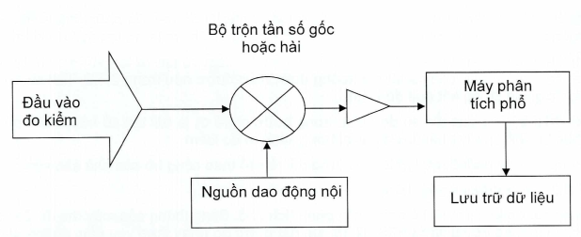
Test inputs
Internal oscillator
Data storage
Spectrum analyzer
Fundamental or harmonic mixer
Figure 2 - Diagram of test setup of out-of-band radiation for the frequency band above 40 GHz
Out-of-band emissions of the signal in the normal modulation mode shall be measured and recorded over the frequency range adjacent to the operating frequency range specified in Table 1, up to a frequency at which the emission level is less than 50 dB relative to the maximum emission level.

3.2.4. Measurement of spurious emissions
This measurement method is applicable to transmitters with integral antennas.
a) In this measurement the full use of the specified frequency ranges shall be required.
Initially, the test antenna is vertically polarized and connected to the measuring receiver, through a suitable filter to avoid overload of the measuring receiver if necessary. The bandwidth of the measuring receiver shall be adjusted to such an extent that its receive sensitivity is 6 dB below the unwanted emission limits shown in Table 3, clause 2.1.3.2. This bandwidth shall be included in the test report.
To measure spurious radiation below the 2nd harmonic of the carrier frequency, a notch filter (“Q” notch filter) centered at the carrier frequency, with a signal loss of at least 30 dB, should be used.
Transmitters under test shall be mounted on a stand in the reference position and shall be left in the nonmodulation mode (see B.1 of Appendix B). If the modulation cannot be stopped and the test must then be performed in the modulation mode, this shall be included in the test report.
b) The measuring receiver shall be adjusted between 30 MHz and 2,2 times of the carrier frequency, except for the channels on which the transmitter is intended to operate. The frequency of each identified unwanted emission shall be recorded. If the test sites are subject to external interference, widen the display and reduce the distance between the transmitter and the test antenna to find a good value.
c) At each frequency at which an emission occurs, the measuring receiver shall be adjusted and the test antenna shall be raised or lowered through the specified height limit until a maximum signal level is reached on the measuring receiver.
d) The transmitters are rotated in 360° around the vertical axis, to maximize the received signals.
e) The test antennas are raised or lowered again through the specified range of heights up to the received maximum level. This level will be recorded.
f) At each frequency at which an emission occurs, the signal generators, replacement antenna and measuring receiver shall be adjusted. The test antenna is raised or lowered within the specified height until the maximum signal level is reached on the measuring receiver. The level of the signal generator for the analog signal level on the measuring receiver as stated in e) shall be recorded. After further correction for the replacement antenna gain and cable loss between the signal generators and the replacement antenna, this is an unwanted emission at this frequency.
g) The frequencies and levels of each measured emission and the bandwidth of the measuring receiver shall be included in the test report.
h) Steps c) to g) shall be repeated with the test antenna that is horizontally polarized
i) If the power adjustment feature is used, the test steps from c) to h) shall be repeated at the lowest power level.
j) Steps c) to h) shall be repeated with the transmitter in the standby condition if this option is available.
The sensitivity of the spectrum analyzer shown to background noise is at least 6 dB above the limit given in Table 5. To improve the sensitivity of the measuring receiver, the measurement bandwidth or measuring distance may be reduced. If this is not done, background noise during the test shall be included in the test report.
As recommended in Clause 3 of CEPT/ERC 74-01, spurious emission domain limits are applied to the frequency range from 9 kHz to 300 GHz. However, subject to the conditions, the frequency ranges of spurious emission measurements may be limited, ensuring that the limits are met. Refer to Clause 3 of CEPT/ERC recommendation 74-01 for further guidance.
NOTE: Testing at higher frequencies may not determine measurement uncertainties due to the lack of key references. In addition, further simplification of the test technique saves time/cost, while it is possible to ensure the fulfilment of the requirements.

3.3. Test on receivers
This measurement method is applicable to transmitters with integral antennas.
a) In this measurement, the full use of the test site of the specified frequency ranges shall be required.
Initially, the test antenna is vertically polarized and connected to the measuring receiver, through a suitable filter to avoid overload of the measuring receiver if necessary. The bandwidth of the measuring receiver shall be adjusted until the sensitivity of the measuring receiver is at least 6 dB below the unwanted emission limit specified in clause 3.2.3. This bandwidth shall be included in the test report.
The test equipment shall be placed on a stand in the standard position.
b) The measuring receiver shall be adjusted between 30 MHz and 2.2 times of the carrier frequency. The frequency of each detected unwanted emission will be recorded. If the test sites are subject to external interference to find a good value, expand the display and reduce the distance between the transmitter and the test antenna.
c) At each frequency at which a component occurs, the measuring receiver shall be adjusted and the test antenna shall be raised or lowered through the specified height limit until a maximum signal level is reached on the measuring receiver.
d) The receivers are rotated in 360° around the vertical axis, to maximize the received signals.
e) The test antennas are raised or lowered again through the specified range of heights up to the maximum level received. This level will be recorded.
f) At each frequency at which a component is detected, the transmitters, replacement antennas and measuring receivers shall be adjusted. The test antenna is raised or lowered through the specified range of heights until the maximum signal level is reached on the measuring receiver. The level of the signal generator for the analog signal level on the measuring receiver as stated in e) shall be included. After further correction for the replacement antenna gain and the cable loss between the transmitters and the replacement antenna, these values ​​represent unwanted radiation components at this frequency.
g) The frequencies and levels of each measured emission and the bandwidth of the measuring receiver shall be included in the test report.
h) Measurements from c) to g) shall be repeated with the test antenna that is horizontally polarized.
As recommended in Clause 3 of CEPT/ERC 74-01, the spurious emission domain limits of the radio equipment considered herein are applied to the frequency range up to 300 GHz. However, for practical measurements only, the frequency ranges of spurious emission measurements may be limited. For further guidance, refer to Clause 3 of CEPT/ERC 74-01.

4. REQUIREMENTS FOR MANAGEMENT
4.1. General short range devices within the scope specified in Article 1.1 shall comply with the provisions of this regulation.
4.2. The test of technical specifications in this regulation in order to provide conformity certification and announcement shall comply with the applicable regulations. Organizations and individuals are allowed to use measurement/ test results of designated domestic testing laboratories, or recognized foreign testing laboratories or accredited domestic and foreign laboratories in accordance with ISO/IEC 17025, or the manufacturer's measurement/test results.

5. RESPONSIBILITIES OF ORGANIZATIONS AND INDIVIDUALS
The relevant organizations and individuals shall comply with the provisions on conformity certification and announcement of equipment within the scope of this regulation and subject to inspection by the State authorities in accordance with the applicable regulations.

6. ORGANIZATION OF IMPLEMENTATION
6.1. The Authority of Telecommunications, the Department of Radio Frequency and the Departments of Information and Communications shall organize the implementation, guidance and management of equipment under the scope of this regulation.
6.2. Where the provisions mentioned in this regulation are changed, supplemented or replaced, the provisions of the new document shall apply.
6.3. During the implementation of this Regulation, if any problem arises, relevant organizations and individuals shall report it in writing to the Ministry of Information and Communications (Department of Science and Technology) for guidance and settlement./.

Appendix A
(Normative)
Radiation measurements
A.1. Replacement measurement
The replacement measurement can be used without guaranteeing the suitability of the test site, since the error of the measurement site at certain frequencies will be constant and can be offset through the replacement measurement. The accuracy of the measurement depends mainly on the accuracy of the RF transmit parameters and the gain value of the replacement antenna.
A.1.1. Principle of replacement measurement
When the radiated power is evaluated by the replacement measurement, the peak power will be calculated.
The use of the error evaluation method of “test site comparison” reduces the measurement uncertainty value. The disadvantage of this method increases the measurement period since many parameters must be determined for an EUT.
A suitable description of “test site comparison” is shown in Figure A.1. Figure A.1 includes: an antenna without power absorption parameters (1) providing a sufficiently wide opening angle, with a height-adjustable support (2), an antenna cable (3) and a display unit that is a measuring receiver or spectrum analyzer or a power meter (4).
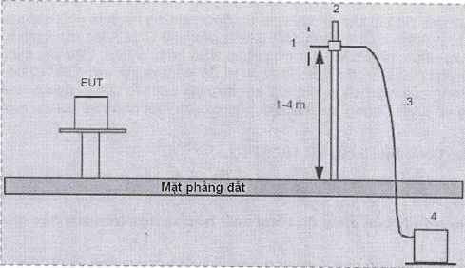
Ground plane
Figure A.1 — First step of replacement measurement
In the first step of the replacement measurement, the maximum emission level of the EUT is determined. This level has no units and does not represent the measured value. It gives a reference value.
The replacement measurement site Area 2 in Figure A.2 includes a unmodulated, variable frequency and power transmitter, whose power value can be evaluated by calibration or comparison with a calibrated meter (1), a 50Ω cable with appropriate attenuations (2), attenuator (3) for connection to the antenna, including actual impedances, an antenna holder that does not affect the test results (4) and a standard dipole antenna up to 1 GHz or an antenna with an equivalent correction or isotropic gain (5).
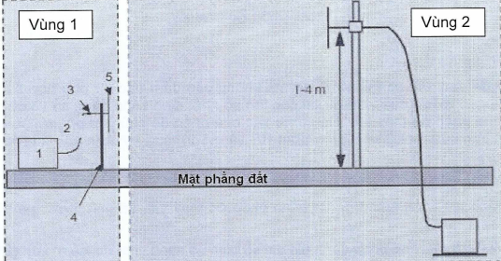
Area 2
Ground plane
Area 1
Figure A.2 - Second step of replacement measurement
For the measured frequencies, in the second step, the transmitter generates a power level corresponding to the readings in the first step.
A.2. Pre-replacement measurement
The pre-replacement measurement is a simplified procedure and is unable to change the replacement. It is only possible when the measurement site is proven to be suitable for the specific test frequency range in the range of 30 MHz to 100 GHz. The corresponding verification can be performed by NSA or S_{VSWR} method. It is difficult to perform this verification at test sites other than the open area test site (OATS) due to the resonant effects of the metal screen combined with the effects of radio absorbers, in which there are six reflectors compared to one reflector of the OATS.
See also Article 5 of TR 102 273-2.
Another common disadvantage is that, even if there are sufficient frequency steps, it shall be interpolated between those frequency steps, resulting in increased measurement uncertainties.
A.2.1. Principle of radiated power measurement based on attenuation of test site
The pre-replacement measurement may evaluate peak radiated power and other types of radiated power.
Due to the influence of the test site and measuring device, this method increases measurement uncertainty in which the increase is equivalent to the field strength measurement in CISPR 16. It is necessary to re-evaluate and further review with a replacement measurement so that the measurement results are close to the threshold value.
To determine the attenuation of the measurement site, a test site that complies with the requirements of CISPR 16-1-4 and an RF source shall be required. This source consists of a standard dipole antenna up to 1 GHz or an antenna with calibrated equivalent isotropic gain (1), an antenna holder that does not affect the test results (2), a compensator calibrated (3) and matched to the antenna adaptation factor, including active resistors, a 50Ω cable with suitable cable attenuations (4) and a unmodulated, variable frequency and power transmitter, with power values ​​which can be evaluated by calibration or comparison with a calibrated meter (5).
At the same time, an additional power measuring device that is require includes: An antenna with specified gain parameters (6), height-adjustable support (7), a 50 Ω cable with a specified attenuation (8) and a calibrated measuring receiver (9).
The antenna (1) shall be placed as far as possible, at the same height as the EUT, before it is replaced on the basis of measurements. It should be noted that the polarization of both antennas must be the same. The previously known radiated power is generated at the output of the RF source. The test antennas shall be adjusted to the height at which the measured power reading at the receiver is highest (9). This power will be recorded. The difference between the transmit power and the receive power in dB is the attenuation at the test site. The attenuation of the test site shall be determined with all frequency steps in the rated frequency range and these values ​​shall be recorded.
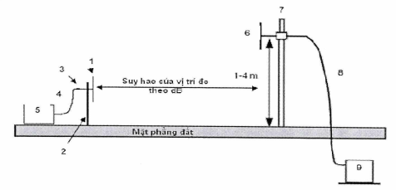

Attenuation of test site in dB
Ground plane
Figure A.3 - Example of a test site based on the attenuation of the test site
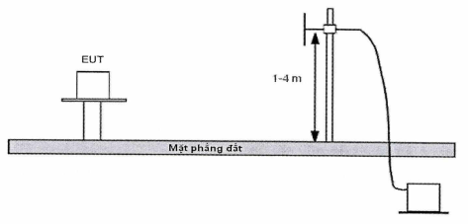
Ground plane
Figure A.4 - Example of a test site based on the attenuation of the test site
In the actual measurement, the radiated power is determined by the measured value and the attenuation value at the test site in units.

Appendix B
(Normative)
General conditions
B.1. Signal and normal test modulation
The test modulation signal is the signal used to modulate the carrier, subject to the type of equipment under test and the required measurement. The test modulation signal applies only to the equipment with an external modulation connector. For equipment without an external modulation connector, the internal modulation of the equipment shall be used for testing.
The used test signal has the following characteristics:
- Represent the normal operating process.
- Make the largest occupied RF bandwidth
For discontinuous transmitters, the test signal shall be such that:
- The generated RF signal is the same for each transmission.
- Transmission occurs in a stable manner over time.
- The transmitted signal sequence is repeated exactly.
Details of the test signal shall be included in the test report.
Where no external test modulation is specified, the internal modulation of the equipment shall be used for testing.
B.1.1. Test signal for data transmission
For the equipment with an external connector for data modulation, the test signal shall be as follows:
D-M2: The test signal is a pseudorandom binary sequence of at least 511 bits, repeated continuously, in accordance with Recommendation ITU-T O.153. If the signal sequence is not repeated continuously, the actual method of application should be indicated in the test report.
D-M3: The test signal shall be agreed between the testing laboratory and the equipment supplier where selective messages are used, generated or decoded within the test equipment. This test signal may be formatted and may contain error detection and correction codes.
B.1.2. Product information
The following parameters shall be declared by the manufacturer of the equipment to carry out the measurements, in order to declare conformity:
a) Operating frequency channels: Means the center frequencies that the EUT is capable of adjusting. If equipment is capable of supporting multiple sub-channels (e.g. allowing operation with different channel widths), these frequency channels shall be declared.
b) Types of modulation used by the EUT.
c) The line access methods used by the EUT.
d) Description of the integral antennas used by the equipment and the measures to prevent users from connecting to another antenna
B.1.3. Tests on frequency hopping devices
The test should be performed on a frequency within ±20 ppm of the highest hopping frequency and the lowest hopping frequency. For a special frequency hopping device, three different tests should be carried out under the above conditions, as follows:
a) The frequency hopping sequence is intercepted and the equipment is tested on two different channels as stated above.
b) The frequency hopping sequence is active and the equipment is tested on two hopping channels as stated above, the channels are accessed sequentially and the number of visits to each measurement is equal.
c) The frequency hopping sequence operates normally and the equipment is tested on all hopping channels as declared by the manufacturer.
B.2. Test area and radiation measurements
B.2.1. Test fixture
B.2.1.1. Requirements
The test fixture for radio equipment that operates in the relevant frequency range shall enable the EUT to be physically supported, together with a wave-guide horn antenna, which is be used to measure the transmitted energy, in a fixed physical relationship to the EUT or the calibrated antenna Tx. The test fixture shall be designed for use in an anechoic environment and allow certain measurements to be performed in the far field, i.e. at a distance greater than 2d²/λ, where d is the EUT's largest dimension of the antenna aperture.
The test fixture shall incorporate at least a RF connector, a device with electromagnetic couplings to the EUT and a device for locating the EUT. Its compactness shall be permissible during the entire test and will be appropriate in the case of an anechoic suite, usually an air-conditioned facility. Circuits associated with RF coupling devices shall contain no active electrical equipment or non-linear components.
Only after it has been verified that the test fixture does not affect performance of the EUT, the EUT can be tested confidently.
During the preparation phase, the EUT shall be connected to the test fixture so that the maximum output power is measured. The direction of the antenna will be included in the EUT's polarization data.
In addition, the test fixture shall provide a connector to an external supply.
The test fixture shall be provided by the equipment manufacturers with full description, evaluated and selected by an accredited testing laboratory.
The performance characteristics of the test fixture shall be measured and selected through an accredited testing laboratory. It shall comply with the following relevant and basic parameters:
- the gain of the waveguide horn does not exceed 20 dB;
- The minimum distance between the transmitting antenna and the receiving antenna shall ensure mutual interaction under actual conditions (distance greater than 2d²/λ), where d is the EUT's largest dimension of the antenna aperture).
NOTE 1: The information on measurement uncertainty and verification procedures are detailed in Clauses 5 and 6 of TR 102 273-6, respectively.
NOTE 2: The far-field conditions of the test setup must be carefully verified in the frequency bands specified in this regulation. The voltage standing wave ratio (VSWR) at the waveguide flange at which measurements are made is not greater than 1,5.
- The performance of the test fixture when mounted in the anechoic chamber or in a temperature chamber shall not be affected by the contact of people or objects inside the chamber. The test performance may be repeated after the EUT is replaced and removed;
- The performance of the test fixture shall remain within the limits indicated in the test report, when the test conditions change within the limits described in 3.1.1.2 and 3.1.1.3. The characteristics and calibration of the test fixture shall be shown in the calibration report.
B.2.1.2. Calibration
The calibration of the test fixture establishes the relationship between the output from the test fixture and the transmitted power (as sampled at the position of the antenna) from the EUT in the test fixture. This can be achieved by using a horn antenna with a gain equal to or less than 20 dB, provided by an external signal source, in place of the EUT to determine changes in power values with temperature and over frequency.
The test fixture shall be calibrated by each EUT manufacturer or by an accredited testing laboratory. These results shall be approved by accredited testing laboratories.
Calibration shall be carried out in the operating frequency bands, at least 3 times, for the declared polarization of the EUT.
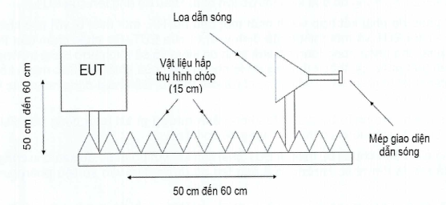
50 cm to 60 cm
Waveguide interface flange
Pyramid absorber
(15 cm)
Waveguide horn
50 cm to 60 cm
Figure B.1 - Example of a test fixture
For more detailed information on the usage, validation and performance limits of test fixtures up to 100 GHz, see TS 103 502.
B.2.2. Test sites and general arrangements
B.2.2.1. Open-Area Test Site (OATS)
The open-area test site consists of a turntable at one end and a height-adjustable antenna at the other end, both located above a ground plane, which in the ideal case is conductive and infinite. In fact, it is possible to create a well conductive plane, but it is not possible to create an infinite plane. Figure B.2 describes a typical open-area test site.
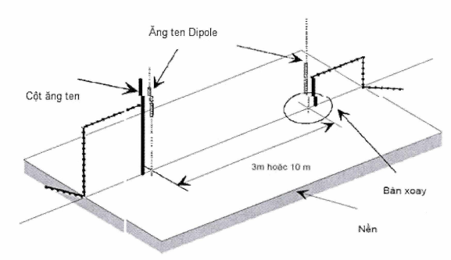
Antenna mast
Dipole antenna
3 m or 10 m
Ground plane
Turntable

Figure B.2 - Typical Open-Area Test Site
The ground plane produces the desired reflections, so the receiving antenna will receive a signal that is the sum of the transmitted signal and the reflected signal. For each of the transmit (or EUT) and receive antenna heights above the ground plane, the phase difference between these two signals will produce a single receive level.
In fact, the straight antennas have variable height so that the height of the test antenna is optimized for the signal, combined with the turntable to produce the azimuth.
Both absolute and relative measurements can be made at the open-area test site. In the case of an absolute measurement, it is necessary to verify the OATS so that the measurement can be made at the recognized test site. The comparison of measured performance shall be considered ideal in terms of ​​a theoretical position, so the acceptance shall be determined on the basis that the difference does not exceed a predetermined limit.
B.2.2.2. Other test sites
The test sites described below are equipped with absorbers to reduce reflections. The absorbers are able to provide an upper and lower limit for the frequency. For use at high frequencies in accordance with these test sites, it is necessary to test the attenuation of reflection and resonance in the test suite.
B.2.2.3. Anechoic chamber with a ground plane.
The anechoic chamber with a ground plane is a closed test suite, in which the inner surface of the walls and ceiling is covered with a layer of RF absorber which is usually a type of urethane foam and has a pyramid shape. Its ground plane is made of bare metal (uncoated) and flat. Typically, the test suite consists of an antenna mast at one end and a turntable at the other. Figure B.3 describes a typical anechoic chamber with a ground plane.
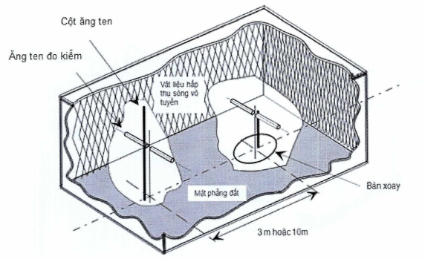
Radio absorber
Test antenna
Antenna mast
Turntable
3 m or 10 m
Ground plane
Figure B.3 - A typical anechoic chamber with a ground plane
This type of test suite attempts to simulate an open-area test site (OATS) whose main feature is an ideal ground plane that is infinitely extended.
The shielding of the test suite, combined with the use of radio absorbers, is intended to create a controlled environment in the test suite. The shielding creates the test environment, reducing interference from surrounding signals and other external effects, while the radio absorber minimizes unwanted reflections from walls and ceilings, which may affect the measurement.
In fact, it can be easily shielded to reject ambient noise at a high level (80 dB to 140 dB) (ambient noise can often be ignored) because no radio absorber is intended to absorb all the energy sources. For example, it is not manufactured and configured perfectly, so its attenuation of reflections (a measure of efficiency) also varies with frequency, angle of incidence. In some cases, it is also affected by the high power level of the energy from the incident radio waves. To improve the attenuation of reflections over a wider frequency range, ferrite bricks, ferrite meshes and hybrid materials between urethane foams and ferrite bricks are used.
The ground plane will produce the desired reflections, so the receive antenna will receive a signal that is the sum of the transmitted signal and the reflected signal. For each of the transmit (or EUT) and receive antenna heights above the ground plane, the phase difference between these two signals will produce a single receive level.
In fact, the antenna mast has variable height, so that it is possible to choose the exact position of the test antenna combined with the turntable at which the sum of the two signals between the azimuth and the antenna, or between an EUT and a test antenna is maximum.
Both absolute and relative measurements can be made in a fully anechoic chamber. The test suite shall be pre-verified at the place where absolute measurements are taken or at the place where recognized tests are performed. This test involves a comparison of measurement performance with a theoretically ideal suite, so the acceptance shall be determined on the basis that the maximum difference between the two types of suites does not exceed the given limit.
B.2.2.4. Anechoic chamber
The anechoic chamber is usually a shielded, closed test suite in which the interior of the walls, ceiling and floor is covered with a layer of radio absorber, generally urethane foam with cone-shaped nodules. Typically, the chamber consists of an antenna mast at one end and a turntable at the other. A typical anechoic chamber is shown in Figure B.4 with dipole antennas at both ends.
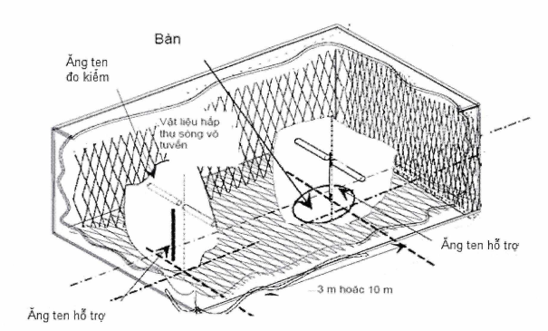
Radio absorber
Supporting antenna
Supporting antenna
3m or 10m
Turntable
Test antenna
Figure B.4 - Typical anechoic chamber
The shielding of the test suite combined with the use of radio-absorbers creates a controllable environment during the test. This type of test suite tries to best simulate conditions in free space. The shielding creates a test space that reduces interference from surrounding signals and other external effects, while the radio absorbers minimizes unwanted reflections from walls, floors and ceilings that can affect the measurement.
In fact, it can be easily shielded to reject high level ambient noise (80 dB to 140 dB) (which can often be ignored), no radio absorber is intended to absorb all the energy sources. For example, it is not manufactured and configured perfectly, so its attenuation of reflections (a measure of efficiency) also varies with frequency, angle of incidence. In some cases, it is also affected by the high power level of the energy from the incident radio waves. To improve the attenuation of reflections over a wider frequency range, ferrite bricks, ferrite meshes and hybrid materials between urethane foams and ferrite bricks are used.
In general, the anechoic chamber has many advantages over other test suites. It is less affected by ambient noise, less reflected from walls, ceilings and floors, and is weather independent. However, it also has some disadvantages: limited measuring distance (due to the size of the test suite, cost, etc.) and usage of lower frequencies, due to the size limitation of the test suite and pyramidal absorbers.
Both absolute and relative measurements can be made in a fully anechoic chamber. The test suite shall be pre-verified at the place where absolute measurements are taken or at the place where recognized tests are performed. This test involves a comparison of measurement performance with a theoretically ideal suite, so the acceptance shall be determined on the basis that the maximum difference between the two types of suites does not exceed the given limit.
A typical anechoic chamber is shown in Figure B.5. This type of test chamber is built to simulate free space conditions.
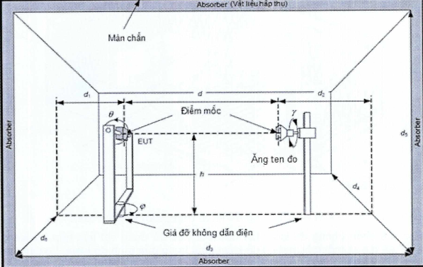
Non-conductive support
Test antenna
Marker
Screen
Figure B.5 - Typical anechoic chamber
The test chamber contains suitable antennas and supports at both ends.
The test antenna and EUT supports should be made of materials with low attenuation of ultrahigh frequency waves and a relatively low value of dielectric constant.
The anechoic chamber shall be shielded. Interior walls, floors and ceilings must be covered with radio absorbers. The shielding and attenuation of reflections produce a wave that is perpendicular to the frequency. Among the common test frequency ranges:
- The shielding attenuation is 105 dB;
- The attenuation of reflection is 30 dB.
Both relative and absolute measurements shall be made in an anechoic chamber. The test suite must be pretested at the places where absolute measurements are taken
The location of the protected anechoic chamber shall be calibrated and validated within the applicable frequency ranges.
NOTE 1: The information on measurement uncertainties and verification procedures are detailed in Clauses 5 and 6 of TR 102 273-2 respectively.
NOTE 2: The test fixture is introduced and the procedures are based on best practice in the low frequency bands. Settings should be adjusted to the specific needs of millimeter wave systems, especially frequencies above 100 GHz. The test results should clearly show how the test fixture is set up. The proposed test fixture is intended primarily for a power test as defined within the scope of this regulation.
When the test is carried out in an anechoic chamber above 1 GHz without sweeping the reference antenna height, instead of performing a 360° rotation with the EUT turntable, it is necessary to move it over all its surfaces to measure the maximum RF radiated power because narrow antenna patterns occurs at high frequencies.
B.2.2.5 Minimum requirements for test sites for measurements above 18 GHz
In general, the test sites shall be sufficient to carry out the far-field test of the EUT. Therefore, the test site shall consist of an electromagnetic anechoic chamber or at least the ground plane covered with radio absorbers or up to six surrounding surfaces covered with radio absorbers. Absorbers shall provide a minimum attenuation of 30 dB. It shall be verified that reflections are sufficiently reduced. The test sites shall have the following dimensions:
- Width of 2 meters.
- Length of 3 meters.
- Height of 2 meters (only applicable to a suite with more than one reflector).
The height of the directional receive antenna reduces reflections. It is recommended to use a horn antenna with standard gain. It shall be noted that if the antenna aperture is smaller than the EUT, measurements shall be made sufficiently both in azimuth and elevation to ensure that maximum radiation is determined. The measuring distance shall be selected in such a way that antenna coupling effects are avoided. Therefore, it is recommended to use a minimum distance of 0.5 m. The EUT can be placed at any height to minimize reflections from the floor.
Due to the high attenuation of coaxial cable at high frequencies, the connection from the receive antenna to the measuring receiver should not exceed 1m, thus making it necessary to place the measuring receiver close to the receive antenna. This is especially the case when using an external harmonic mixer with very short connections to the measuring receiver. Therefore, the measuring receiver should somehow be covered with radio absorbers in the direction of the measuring field to reduce reflections. Figure B.6 shows an example of a test site above 18 GHz with one reflector.
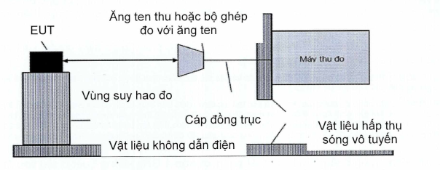
Receive antenna or test fixture with antenna
Non-conductive material
Radio absorber
Site attenuation
Measuring receiver
Coaxial cable
Figure B.6 - Example of a test site above 18 GHz with one reflector
The site attenuation of the test site can be determined. If the test site with its characteristics is nearly ideal, it may be possible to use the theoretical Free Space Loss (FSL) as site attenuation as shown in the examples in the Tables B.1 to B.3.
Table B.1 - Example of Free Space Loss at a distance of 1m
Measuring distance (m) | f (GHz) | λ (1 m) | FSL (dB)
0.5 | 24.2 | 0.012397 | 60.12
 | 48.4 | 0.006198 | 66.14
 | 72.6 | 0.004132 | 69.66
 | 96.8 | 0.003099 | 72.16
Table B.2 - Example of Free Space Loss at a distance of 0.5 m
Measuring distance (m) | f (GHz) | λ (1 m) | FSL (dB)
0.5 | 24.2 | 0.012397 | 54.1
 | 48.4 | 0.006198 | 60.12
 | 72.6 | 0.004132 | 63.64
 | 96.8 | 0.003099 | 66.14
Table B.3 - Example of Free Space Loss at a distance of 0.25 m
Measuring distance (m) | f (GHz) | λ (1 m) | FSL (dB)
0.25 | 72.6 | 0.004132 | 57.62
 | 96.8 | 0.003099 | 60.12
Where:
λ = c/f
[FSL] = 10 log (4πr/λ)²

Appendix C
(Informative)
Atmospheric absorption and material dependent attenuations
In the frequency range between 40 GHz and 246 GHz, the atmospheric absorption and material dependent attenuations are an important factor for the compatibility of different services sharing the same operating frequency band. This appendix provides an overview of relevant parameters for different materials and atmospheric absorptions.
C.1. Atmospheric absorptions
With higher frequencies, the effect of the atmospheric absorption becomes more and more important in the evaluation of short-range wireless systems. Figure B.1 specifically describes the absorption in the frequency band between 1 GHz and 350 GHz. The graph shows the absorption curve of dry air, H2O, and a combination of the two. It can be seen that under normal conditions the absorption due to H2O is the most significant effect. Dry air also shows the significant absorption of two spectral regions around 60 GHz and 120 GHz. That means these absorptions are independent of the amount of H2O in the air. Especially the absorption peak around 60 GHz will be used to increase the independent operation between different wireless systems. The absorption peak around 60 GHz originates from several oxygen absorption lines. A more detailed description of the behaviour around 60 GHz is depicted in Figure C.2 for different altitudes from 0 km (sea level) to 20 km. In particular, the graph clearly shows the different absorption lines at an altitude of 20 km. The absorption peak around 60 GHz reaches 16 dB/km.
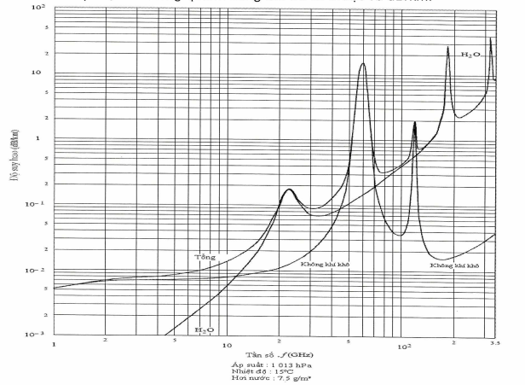
Specific attenuation (dB/km)
Frequency .f (GHz)
Pressure: 1 013 hPa
Temperature: 15oC
Water vapour: 7.5 g/m³
Dry air
Dry air
Total
Figure C.1: Atmospheric attenuation in the frequency band between 1 GHz and 350 GHz (dB/km)
Specific attenuation in the frequency range from 50 to 70 GHz at identified altitudes
(0 km, 5 km, 10 km, 15 km and 20 km)
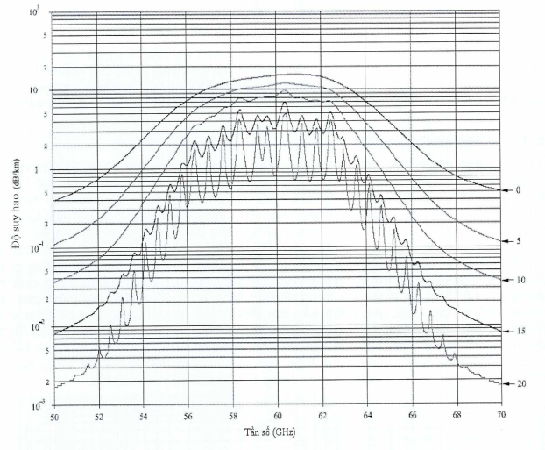
Specific attenuation (dB/km)
Frequency (GHz)
Figure C.2 - Atmospheric attenuation in the frequency band between 50 GHz and 70 GHz at different altitudes (0 km, 5 km, 10 km, 15 km and 20 km)
C.2. Material dependent attenuations
The material dependent attenuation also increases with the operating frequency. Typical attenuations for different materials are described in Figure C.3 for the frequency range between 3 GHz and 200 GHz. These effects are important when coexistence scenarios are investigated between indoor and outdoor systems.
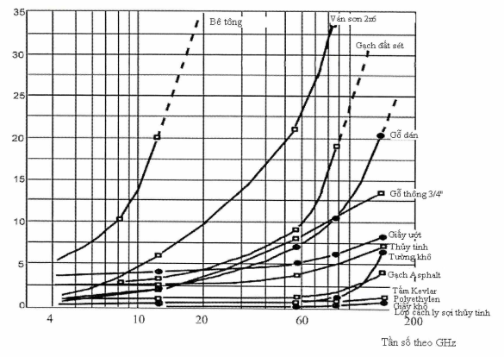
Frequency in GHz
Concrete block
Painted 2x6 board
Clay brick
Plywood
Wet paper
3.4” pine wood
Glass
Dry wall
Asphalt shingle
Dry paper
Kevlar sheet
Fiberglass insulator
Figure C.3: Material dependent attenuation at high frequency in the frequency range from 3 GHz to 200 GHz in dB

Appendix D
(Normative)
Regulations on the HS codes of short range devices to be used in the 40 GHz to 246 GHz frequency range
No. | Name of products and goods as stated in QCVN | HS code | Description
1 | Short range device (SRD) - Radio equipment to be used in the 40 GHz to 246 GHz frequency range | 8517.62.59  8526.10.10  8526.10.90  8526.92.00 | Radio devices used for alarms, telemetry, telecommand, data transmission, operating in the 40 GHz to 246 GHz frequency range specified in Table 1 of this Regulation in the following cases:  - With a radio frequency output connection and dedicated antenna or with an integral antenna;  - With all types of modulation;  - Fixed stations, mobile stations and portable stations.

Appendix E
(Informative)
Technical requirements and measurement methods for short range device (SRD) - radio equipment to be used in the 57 GHz to 64 GHz frequency range
E.1. Technical requirements for transmitters
E.1.1. Power spectral density
E.1.1.1. Definition
The power spectral density means the mean equivalent isotropic radiated power (e.i.r.p.) in dBm per MHz during transmission.
E.1.1.2. Limits
The maximum power spectral density is applicable to the equipment operating at the highest declared power level. For smart antenna systems and directional antennas, this limit applies to the configuration to achieve the highest PSD (e.i.r.p.).
The power spectral density limit shall not exceed the value specified in Table E.1.
Table E.1 - Power Spectral Density Limits
Frequency band | Power spectral density (e.i.r.p.) | Application
57 GHz to 64 GHz | 13 dBm/MHz | Use for general purposes
NOTE: The requirements for power spectral density apply only to transmitters, transceivers operating in the 57 GHz to 64 GHz frequency range (excluding the equipment that only operates in the 61.0 GHz to 61.5 GHz frequency range).
E.1.1.3. Measurement methods
The measurement methods are specified in E.3.1
E.1.2. RF output power
E.1.2.1. Definition
See 2.1.1.1.
E.1.2.2. Limits
The maximum RF output power corresponds to the system operating at the highest declared power level. For smart antenna systems and directional antennas, this limit corresponds to the configuration to achieve the highest e.i.r.p.
The RF output power limit in the broadband operation mode shall not exceed the value specified in Table E.2 below.
Table E.2 - RF output power limits
Frequency band | RF output power (e.i.r.p.) | Application | Remarks
57 GHz to 64 GHz | 100 mW (20 dBm) | Use for general purposes | See NOTE
NOTE: The maximum output power of the transmitter is 10 dBm.

E.1.2.3. Measurement methods
The measurement methods are specified in 3.2.1.
E.1.3. Permitted operating frequency range
E. 1.3.1. Definition
See 2.1.2.1.
E.1.3.2. Limits
The frequency range of the equipment measured from the lowest frequency (f_{L}) to the highest frequency (f_{H}) is limited by the power spectrum envelope. In equipment that allows adjustment or selection of different operating frequencies, the power envelope occupies different positions in the allocated frequency band. This frequency range is defined by the lowest values ​​f_{L} and the highest values ​​f_{H}, determined from the adjustment of the device from the lowest operating frequency to the highest operating frequency.
The occupied bandwidth (equal to 99% of the wanted radiated power) and the required bandwidth shall be within the assigned frequency band.
The permitted operating frequency range of the equipment shall be within the 57 GHz to 64 GHz frequency band.
E.1.3.3 Measurement methods
The measurement methods are specified in 3.2.2.
E.1.4. Out-of-band emissions
According to CEPT/ERC recommendation 74-01 and Recommendation ITU-R SM.329-12, the boundary between the out-of-band emission domain and spurious emission domain is ±250 % of the required bandwidth from the central emission frequency.
E.1.4.1. Definition
See 2.1.3.1
E.1.4.2. Limits
The boundary values of the out-of-band emission domain and spurious emission domain ​​depend on the occupied bandwidth of the EUT.
The boundary limit is determined as follows:
F₁ = center frequency of OBW [GHz] - (2.5 * (f_{H} - f_{L}))
F₂ = center frequency of OBW [GHz] + (2.5 + (f_{H} - f_{L}))
Where, the center frequency of the OBW is the center frequency of the signal.
This calculation is given to determine the out-of-band and spurious emission domain boundaries, which will be greater than/less than the maximum value in the permitted operating range (see Figure 1).
In addition, it is possible to calculate F₁/F₂ as follows: If F₁/F₂ is considered as the theoretical lower or upper frequency which come out of the calculation based on 250 % of the maximum value of the OBW (see Tables E.1 and E.2). Therefore, the amplitude between OOB and spurious emission will be fixed at the frequency given in Table E.3 below (normally F₁/F₂ is calculated as 250 % of the center frequency of the signal).
Maximum value of OBW
Table E.3 - Limits of frequency values F₁ and F₂, based on the maximum theoretical OBW of the EUT
Frequency Band | Center frequency | Maximum OBW | F1 | F2
57 GHz to 64 GHz | 60.5 GHz | 7 MHz | 43 GHz | 78 GHz
The value of the radiated power density based on the RMS value in the OOB range (between F₁ ≤ f < f_{L} and f_{H} < f ≤ F₂) shall not exceed the values specified in Tables E.4 and E.5 below.
Table E.4 - Out-of-band emission domain
Frequency [GHz] | RMS power density [dBm/MHz]
F₁ ≤ f < f_{L} | See Table 6
f_{H} < f ≤ F₂ | See Table 6
Table E.5: Limits for out-of-band radiation
Frequency band | OOB limit [dBm/MHz]
57 GHz to 64 GHz | -20 dBm/MHz
2.1.4.3. Measurement methods
The measuring methods are specified in 3.2.3
E.1.5. Spurious emission
E.1.5.1. Definition
Spurious emissions are emissions on one or more frequencies that are outside the required bandwidth and whose value can be reduced without affecting the transmission of information. Spurious emissions include harmonic emissions, parasitic emissions, intermodulation components and frequency conversion components, but exclude out-of-band emissions.
Spurious emissions are measured as power spectral density under normal operating conditions. According to CEPT/ERC recommendation 74-01 and Recommendation ITU-R SM.329-12, the boundary between spurious and out-of-band emission domains emission is ±250 % of the required bandwidth of the center frequency emission.
The frequency ranges to be evaluated in the spurious emission domain are:
- Frequency f < F₁ [GHz]
and
- Frequency f > F₂ [GHz]
The way to determine the values ​​of these frequencies is given in E.1.4.2, the minimum and maximum values ​​are given in Table E.3 above.
E.1.5.2. Limits
See 2.1.4.2
E.1.5.3. Measurement methods
The measurement methods are specified in 3.2.4.
E.2. Technical requirements for receivers
See 2.2.
E.3. Measurement methods for transmitters
E.3.1. Measurement of power spectral density
The maximum mean power spectral density, subject to the test conditions specified in 3.1, shall be measured and recorded. The maximum mean power spectral density is determined using a spectrum analyzer with the appropriate bandwidth for each modulation type and used in conjunction with an RF power meter.
For the purposes of this test, the operating period of the transmitter should be at least 10 μs. For equipment where the operating period of the transmitter is less than 10 μs, the measurement method shall be included in the test report.
The test steps are as follows:
Step 1:
The spectrum analyzer shall be set as follows:
a) Center frequency: The center frequency of the test channel.
b) Resolution bandwidth: 1 MHz.
c) Video bandwidth: 1 MHz (≥ resolution bandwidth).
d) Frequency span: 2 x channel bandwidth declared by the manufacturer.
e) Detector: Peak.
f) Trace mode: Max hold.
Step 2:
When the detection is completed, find the peak value of the power envelope and record the corresponding frequency value.
Step 3:
The settings of the spectrum analyzer are changed as follows:
a) Center frequency: The frequency band recorded in Step 2.
b) Resolution bandwidth: 1 MHz.
c) Video bandwidth: 1 MHz (≥ resolution bandwidth).
d) Frequency span: 3 MHz.
e) Sweep time: 1 minute
f) Detector: Average RMS, sample, or mean (except for displayed average).
g) Trace mode: Max hold.
For devices with occupied bandwidth (OBW) greater than 100 MHz, a resolution bandwidth other than 1 MHz can be used, ranging from 1 MHz to 100 MHz.
In this case the power density limit in Step 4 is defined as follows:
PDL (RBW) = PDL (1 MHz) + 10 x Log₁₀(RBW), where RBW is the used resolution bandwidth in MHz, PDL (1 MHz) is the power density limit with a resolution bandwidth of 1 MHz and PDL (RBW) is the power density limit with the resolution bandwidth set above. The video bandwidth is set at a level equal to the resolution bandwidth and the measurement frequency range is set at a level 3 times as much as the resolution bandwidth.
Step 4
When the detection is completed, use the “View” option on the spectrum analyzer to observe the signal.
Determine the maximum peak value and place the pointer to this value. This value is considered as the highest mean power (power spectral density) PD in 1 MHz (or in another resolution bandwidth as shown above).
Alternatively, in the case of a spectrum analyzer capable of measuring power spectral density, this function can be used to display the power spectral density PD in dBm/1 MHz (or in another resolution bandwidth as shown above).
Where the bandwidth of the spectrum analyzer does not follow a normal (Gaussian) distribution, a suitable correction factor should be used, which shall be included in the test report.
E.3.2. Measurement of RF output power
See 3.2.1.
E.3.3. Measurement of permitted operating frequency range
See 3.2.2.
E.3.4. Measurement of out-of-band emissions
See 3.2.3.
E.3.5. Measurement of spurious emissions
See 3.2.4.
E.4. Measurement method for receivers
See 3.3.

Bibliography of References
[1] ETSI EN 305 550-1 V1.2.1 (2014-10): “Electromagnetic compatibility and Radio spectrum Matters (ERM); Short Range Devices (SRD): Radio equipment to be used in the 40 GHz to 246 GHz frequency range; Part 1: Technical characteristics and test methods”.
[2] ETSl EN 305 550-2 V1.2.1 (10-2014): “Electromagnetic compatibility and Radio spectrum Matters (ERM); Short Range Devices (SRD); Radio equipment to be used in the 40 GHz to 246 GHz frequency range; Part 2: Harmonized EN covering the essential requirements of article 3.2 of the R&TTE Directive”.

